PROGRAM GOAL
To support projects across Michigan that prevent the introduction and spread of aquatic invasive species via the recreational boating pathway through outreach and awareness.
PROGRAM REQUIREMENTS
By completing this application, you agree to the following if your proposal is funded:
- The grantee agrees to host a minimum of three outreach events with CBCW-approved outreach materials.
- Grantee and/or volunteers will review required CBCW training materials (approximately 1 hour of educational instruction).
- Grantee and/or volunteers will collect and report data on the number of people contacted, volunteer hours (if applicable), number of outreach materials distributed, and locations (minimum of waterbody name, county, and township) for all events and signage.
- Grantee will submit one narrative report of all grant-funded activities and expenditures to MSU Extension. A template will be provided to assist with narrative report formatting.
- The narrative report must contain a minimum of five photos of products and/or outreach conducted. The narrative report is due October 31, 2026, or at the time of reimbursement request. Pictures throughout the season are appreciated to share the work conducted.
- Grantee will submit all receipts/invoices for reimbursement by October 31, 2026. MSU Extension will not issue payment to the grantee until all receipts have been submitted. Final payment will be issued within 60 days of receiving receipts and narrative report of grantee activities. Multiple reimbursements are allowable with prior approval before end date on October 31, 2026.

The grantee is required to have written permission (formal permit, printed email, etc.) from boat launch owners and/or managers prior to any project implementation, including sign installations. Grantee is strongly encouraged to reach out prior to proposal submission. For example, Michigan Department of Natural Resources (DNR) Parks and Recreation Division may require a use permit for any events held at DNR owned/managed boating access sites. The grantee is responsible for obtaining permission/s for event sites and if possible, please attach with application beforehand. DNR sites and park managers can be found at Michigan’s Recreational Boating Information System site.

Any materials produced using grant funds from this contract must have approved messaging consistent with outreach campaigns in use in Michigan prior to publication. Creation of signage not aligned with Clean Boats, Clean Waters’ language is not an allowable expense. All materials must be submitted to grant administrators at MSU Extension and the Michigan Department of Environment, Great Lakes, and Energy (EGLE) at least 14 days prior to printing or publication for approval. Any budget or project changes after a grant has been awarded must be approved in writing.

Grantee is required to include recognition of assistance received from the Michigan Clean Boats, Clean Waters program in any promotional or informational materials produced about or by the grant project. Examples of these materials include descriptions of the project in newsletters, informational flyers, signage, or press releases regarding the project. MSU Extension and EGLE logos should not be used on materials to represent support. Michigan Clean Boats, Clean Waters program name and/or logo should be used on all materials. The following language is required for signs and written materials: This project was funded by the Michigan Clean Boats, Clean Waters program and the Michigan Invasive Species Grant Program (Michigan.gov/Invasives).

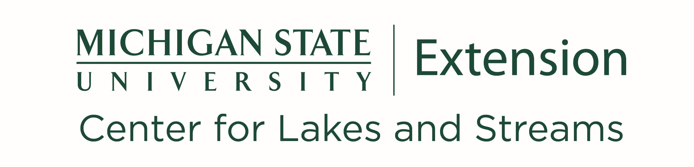

GRANT APPLICATION
Your Michigan Clean Boats, Clean Waters application will need to include the following items: contact information, budget, and grant narrative. Please use this application to submit your information. If you are unable to use this form, contact Kelsey Bockelman (bockelm4@msu.edu). Funding will only be granted to applicants with complete and eligible applications. Applications should be submitted to Kelsey Bockelman (bockelm4@msu.edu), Paige Filice (filicepa@msu.edu), and Kevin Walters (waltersk3@michigan.gov). When submitting to the grant committee, please save all files with the group name included. (Example: CBCW Application 2026_BigLake.docx).

The deadline for applications is January 30, 2026, and applicants will be notified in March 2026 of their award. This funding opportunity is competitive, and complete applications will be ranked based on eligibility, project significance, and overall strategy. Please ensure the contact below is available to receive communication throughout the project period. Note: groups will need a current EIN tax ID number or an SSN from a group member for reimbursement.

GRANT APPLICANT CONTACT INFORMATION
Organization name
Organization type (e.g., lake association, watershed group)
Primary contact name
Mailing address
County
Primary Contact Email Address
Primary Contact Telephone Number
BUDGET PROPOSAL
Please look over the proposed budget for an example grant project below. Some outreach items have a capped cost associated with them. These include the 48” X 48” Clean Boats, Clean Waters Decontamination Station metal sign and hardware ($500/sign bundle), aquatic invasive species removal tools, which can be attached to the metal sign ($150), and boater outreach kits provided by Wildlife Forever ($250). You can request multiples of these items
(e.g., 4 signs at $2000). The maximum allowable expense for staff time and mileage is $700. Note: These project items have a set capped cost per unit as indicated above – please do not change costs. Grantees are responsible for obtaining the items from their own preferred vendor for no more than the capped cost. Funding is available for other approved outreach activities and supplies. Please add them to the Other section.
Provide an itemized budget in a separate document based on the example proposal created below. See the Clean Boats, Clean Waters grant website (canr.msu.edu/cbcw/minigrants) for a template. The budget should include a brief description of items, proposed costs, and locations where outreach materials will be shared. All expenses should coincide with project goals. Total funding requests can be up to $3000.
Limited quantities of EGLE Stop Aquatic Hitchhiker signs (18” X 24” sign) and rack cards may be available through the Michigan Department of Environment, Great Lakes, and Energy at no cost while supplies last. See the Clean Boats, Clean Waters website to learn more.

See example of a proposed grant budget below.

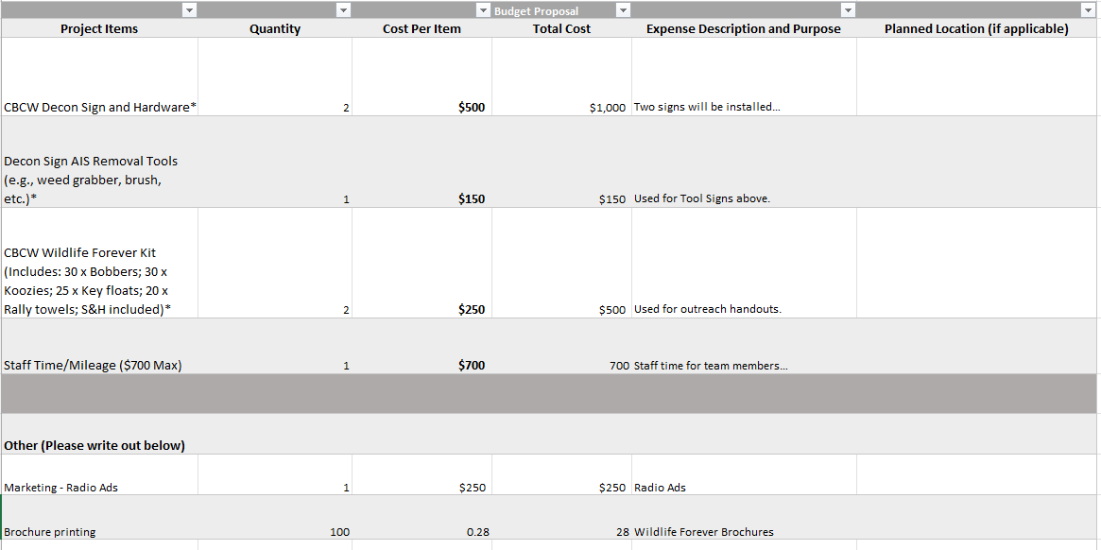
NOTE: Ineligible expenditures include but are not limited to the partial purchase, upkeep and/or the maintenance of a mechanical boat washing station (i.e., boat cleaning systems using high-pressure water, waterless decontamination systems) and indirect costs and fringe for staffing. We encourage applicants to reach out to program staff about project eligibility prior to submitting your application.

GRANT NARRATIVE
Please address the following questions with as much detail as possible:

- What is the purpose for requesting grant funds? Include a project summary, bulleted list of planned activities, anticipated outcomes, and a list of collaborative partners if applicable.

- Please describe your target audience and the anticipated number of people you will educate during this grant project.

- Provide an estimated timeline for when materials will be ordered, and activities/outreach events will take place.

- What makes your organization uniquely positioned for aquatic invasive species boater outreach and education through the CBCW program?

- Provide a short, 3-5 sentence summary of your project that will be used in promotional materials if you are awarded the grant.

